**Migration of LAMIS Facilities’ Data to NMRS**

*The User Guide*

**Pre-requisites:**

* Ensure the existing **webservices.rest** omod in your modules filder is replaced with **webservices.rest-2.29.0**
* Please remember to grant access t everyone in the **Templates** and **Data Files** folders where the data files and templates located so that the migration tool can access them
* You also need to enter the LAMIS ID for this Facility (This is the primary key from the Facility table in the LAMIS Database). This will help to ensure that data for the right facility is migrated in the case where there are more than one facility data in the same LAMIS database
* Also ensure to first provide the correct values for the following variables:

1. partner_short_name
2. partner_full_name
3. facilty_name
4. facility_datim_code
5. nmrs_Database_Name
6. nmrs_Web_Username
7. nmrs_Web_Password
8. nmrs_Server_Port

This can be done in the **AppSettings.json** file in this application's root folder.

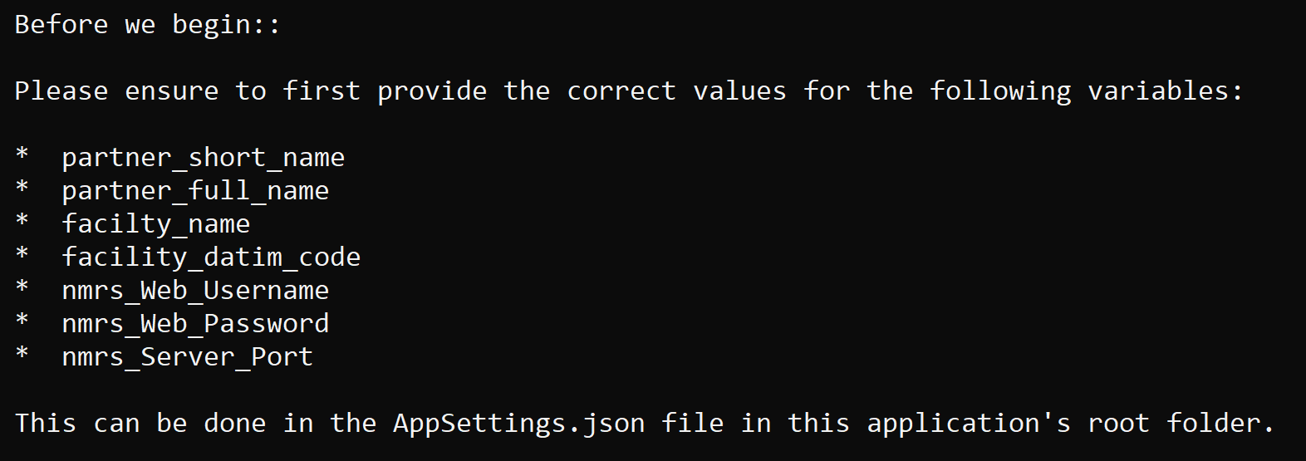

**Migration Options:**

The tool was designed such that one can choose whether to migrate data from LAMIS databases or from data files which are LAMIS data exported to CSV files. You will be presented with the options listed below on the screen. You need to type **1** or **2** and the press the **Enter** key.

1. Migrate from a LAMIS Database
2. Migrate Data from Excel (.xlsx) files

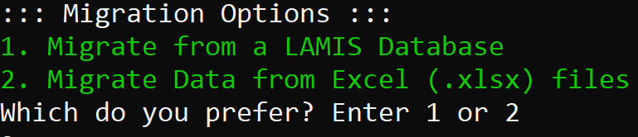

If you choose option 2, that is, to Migrate Data from Excel (.xlsx) files, please ensure that the correct and full file paths for the variables listed below are provided in the AppSettings.json file as well:

**\* patients_Data_File_Path**

**\* clinic_Data_File_Path**

**\* lab_Data_File_Path**

**\* pharmacy_Data_File_Path**

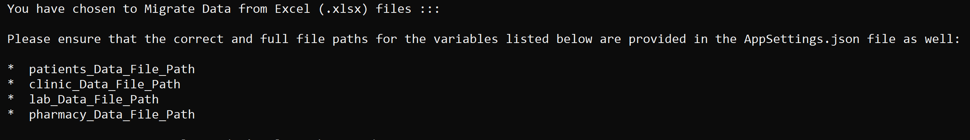

The exported CSV files must be converted to **Excel (.xlsx)** files before migrating the data from the files.

**Data Export to data files:**

For each facility, the appropriate data from the **patient**, **clinic**, and **laboratory** tables can be exported directly to a CSV file from the PG Admin interface, but the data from **pharmacy** table must be generated using the script below. After generating the data with this script, it can then be exported to CSV.

select pharmacy_id,patient_id,facility_id,date_visit, r.description as regimen, rt.description as regimentype,duration,morning,afternoon,evening,adherence,next_appointment,time_stamp from (select * from pharmacy where facility_id = **facility_ID**) as p join (select * from regimen) r on p.regimen_id = r.regimen_id join (select * from regimentype) rt on p.regimentype_id = rt.regimentype_id;

The variable **facility_ID** in the script above must be provided in the case where there are more than one facility data in the database.

If you choose to migrate directly from a database, then ensure that the correct values for the variables listed below are provided in the **AppSettings.json** file as well

**\* lamis_Database_Name**

**\* lamis_Server_Username**

**\* lamis_Server_Password**

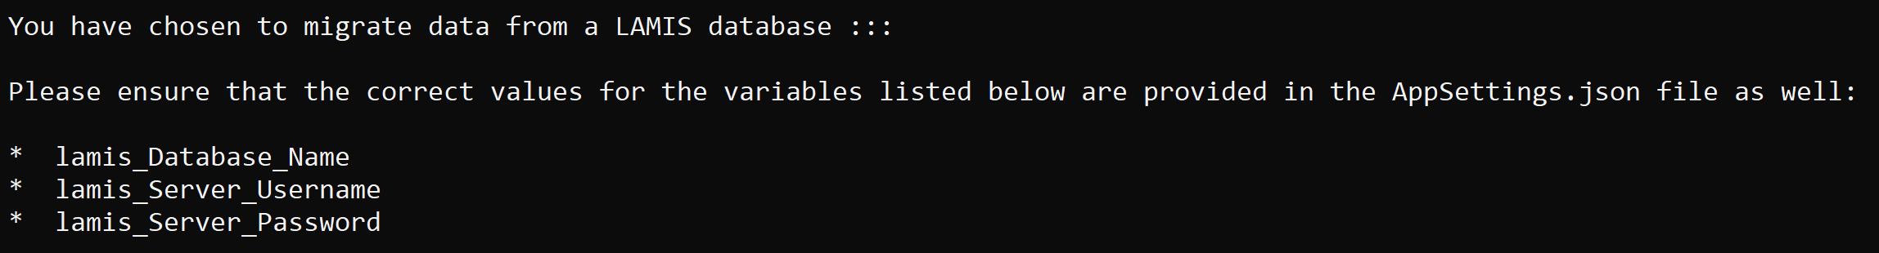

**Compatibility :**

1. **Windows**

Double-click the executable file to launch the application and everything is straight-forward from that point.

1. **LINUX**

Follow the below steps to run your application on Linux:

1. Copy publish folder to ubuntu machine
2. Open ubuntu machine terminal (CLI) and Go to the project directory
3. Provide execute permissions:

chmod 777

./appname

1. Execute application

./appname